Literacy and English - Reading  Scan the next page in your reading book for words you do not know. When you find one stop and work out what the word could be. Try sounding it out, breaking the word into smaller chunks, reading on to see if the sentence helps. | Numeracy and Mathematics – Scavenger Hunt | Health and Wellbeing  Help to make a meal. Ask an adult to help you with chopping things- can you practise the bridge hold in the video below: https://www.youtube.com/watch?v=qN0GCLXfHWY
  Ask someone to make a scavenger hunt for you, for example… In the garden – Find 5 stones, 6 blades of grass; Indoors – Find 4 pens, 7 spoons.
  Challenge: Count how many items you found altogether.
Literacy and English - Vocabulary and Spelling  Use the words your teacher has given you (or some simple ones from the book you are reading). Make flashcards for your words. Write each word on a piece of paper or card. Put them in order of easiest to hardest, Start learning the hardest first! Is the same word still the hardest? | Numeracy and Maths – What Comes After? | STEM  Float or sink?! Choose 10 objects from home (have an adult check these first!) and test whether they float or sink. Try your experiment again, but this time predict whether they will float/sink before you conduct your experiment.
  Choose a number between 1 and 30. What is the number after your number? eg.“What is the number after 17?”. Challenge: Try to say the number after for larger numbers e.g. “What is the number after 39?”. Try to say the number 2 more than your number e.g. “What is 2 more than 9?”.
Literacy and English - Writing Techniques  Use the handwriting rules you have been learning in class. Practise writing your name, on the sheet provided, until you are happy that it is your best work.  Check your work. Can you improve anything? | Numeracy and Maths – Counting Out Loud | Expressive Arts  Draw the same object three ways:  1 .Without letting your pencil leave the page  2. Without looking at your paper- no peeking!  3. With your weaker hand
  Choose a starting number between 1 and 30. Count forwards from that number.
  Challenge: Can you count forwards from a number larger than 30? Can you count forwards with someone, each taking a turn to say a number?
Literacy and English - Writing: Settings  Look at the setting pictures and try to imagine being there. Think about what it would look, feel, sound and smell like.  If you would like a further challenge look at pictures in a book of your own, can you do the same for them? | Numeracy and Mathematics – Count a Collection | Social Studies  Choose somewhere in the world to go on an expedition to. Pack a bag with only three objects to take with you. Why did you choose these and not other things? You could even camp overnight indoors and see if you had the right equipment!
  Count a collection of items e.g. Ask “how many teddies are there?”
  Challenge: Put two collections out and ask “How many altogether?” e.g. 7 spoons and 5 forks.
Literacy and English - Listening and Talking  Choose a member of your family (or a friend) to talk about. As you talk think about the speed and volume of your voice. What can you do to keep the audience interested?  Try your talk out on someone or record it. | Problem Solving  Freddie the spaceman met 17 aliens. Suddenly, 9 aliens were zapped away! How many aliens were left for Freddie to play with? | Health and Wellbeing  Think about ‘big’ feelings that you know or have felt, e.g. frightened, petrified. Consider the facial expressions and body language that go with them. When might people feel these feelings?

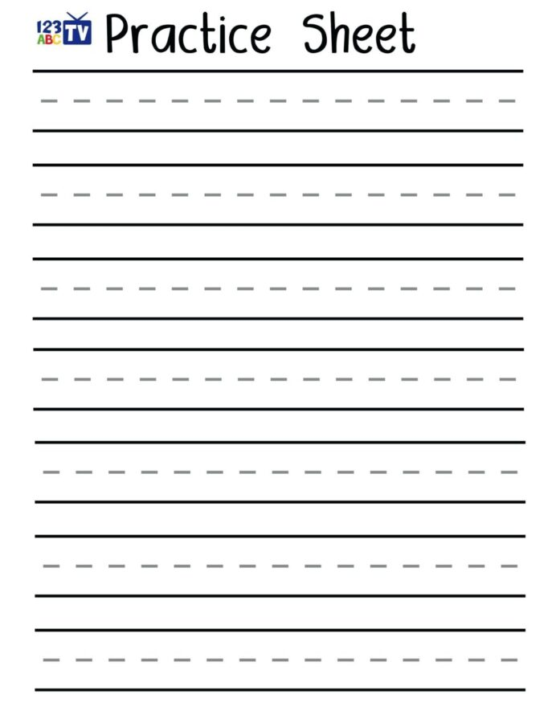
Remember:-
Letters sit on the black line
Tall letters touch both black lines
small letters sit on the black line and touch the ---- line
Some letters hang down under the line

Circle your favourite attempts. Why do you like these ones? What makes them the best?

Choose the sheet with the lines you are most used to.

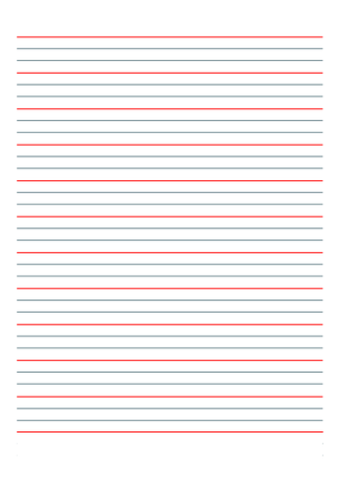

Remember:-
Letters sit on the black line
Tall letters touch both black lines
Small letters sit on the black line and touch the ---- line
Some letters hang down under the line
Circle your favourite attempts. Why do you like these ones? What makes them the best?

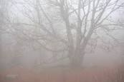

What can you
see? Old trees, dark colours, silhouettes, mist

hear? Leaves crunching, twigs breaking, animal noises

feel? Chill, damp air, frost under feet,

smell? Leaves, earth

Smell?
Think about the following settings. What would you see, hear, feel and smell?

Here is an example.

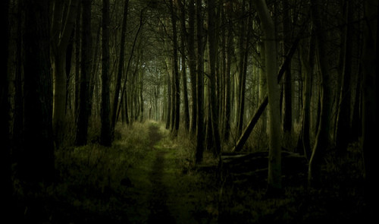

What can you
see?

hear?

feel?

smell?
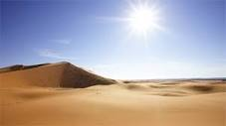
What can you
see?

hear?

feel?

smell?

Smell?

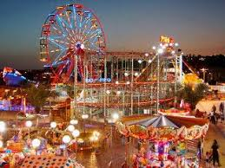
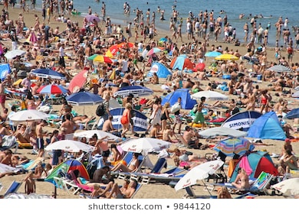

What can you
see?

hear?

feel?

smell?

What can you
see?

hear?

feel?

smell?

