Literacy and English - Reading  Use the title, picture and blurb to select a book to read. Explain why you chose this story. What did you like/dislike about it? Use examples from the book to back up your answers.  Would you read something by this author again? | Numeracy and Mathematics – 3D Object Hunt | Health and Wellbeing  Be a Smile-Spy! Draw a smile on lots of bits of paper and hide them in special places around your home. If someone finds one tell them something that puts a smile on your face. What puts a smile on theirs?
  Go on a hunt for 3D objects in your home. What can you find? Can you name them?
  Challenge: Explore the properties of your object – Which ones roll?, Do any of them stack? Can you sort them e.g. into those which roll and don’t roll.
Literacy and English - Vocabulary and Spelling  Look at the 200 most commonly used word list provided. See how far down the list you can get before you start getting stuck. Learn the next 6 on the list. Get someone to quiz you on them.  Make sure you know what each word means. You could put each in a sentence to prove it. | Numeracy and Mathematics - Sequencing | STEM  Bring the wet weather indoors by creating a cloud in a jar:  https://www.giftofcuriosity.com/weather-science-how-to-make-a-cloud-in-a-jar/
  Sequence numbers in the range 1-100 e.g. write 38, 39, 40, 41 on separate pieces of paper, mix them up then sequence them. Repeat for other sequences.
  Challenge: Can you try to sequence larger numbers? Can you order numbers which aren’t in sequence e.g. 3, 71, 55, 12?
Literacy and English - Question or Statement?  Think about 5 things you would like to tell your friends or teacher. Write them down in sentences. Now think of 5 questions you would like to ask them. Write them down too. Do all your sentences have full stops and your questions have question marks? | Numeracy and Mathematics – Recognising Numbers | Expressive Arts  Fold a piece of paper in half and then in half again so that your paper is split into quarters. On each of the 4 sections draw or paint the weather outside. Repeat on different days so that you have 4 different weather cards that you can put on display in your house.
  Find a number between 1 and 100. Can you say the number out loud? Possible contexts – door numbers, pages in a book, buses.
  Challenge: Look at two of your numbers. Which is larger? Also ask for the number before or after.
Literacy and English - Writing  Choose one of the pictures from the attached sheet. What do you think might be happening? Write at least 3 sentences explaining where, when and why the events are happening. | Numeracy and Mathematics – Dot to Dot Puzzle | Social Studies  Try and learn two different knots and practise them until you don’t need to follow the steps: https://www.animatedknots.com/basic-knots  Where do we use knots? What jobs might need you to be able to tie knots? How have knots been replaced?
  Complete the dot-to-dot puzzle on the back of this sheet.
  Challenge: Can you do it backwards (starting from the largest number)?
Literacy and English - Talking and Listening  Ask a family member for their opinion on something e.g. Should children get pocket money? Under what circumstances? Should homework be banned? Should we have school uniform? Listen to their answers and ask them questions. Show them you value their opinion by allowing them to share it fully. | Puzzle - Code Name  Write the number that represents each letter e.g. A=1, B=2, … Then write your first name in code e.g. Ben would be 2/5/14. Can you write a coded message for a friend? | Modern Foreign Languages  Does anybody at home or in your family speak a different language? Try to learn how to say hello, how to ask someone what their name is or even some different words for fruit and vegetables.  “Les pommes sont magnifiques!”

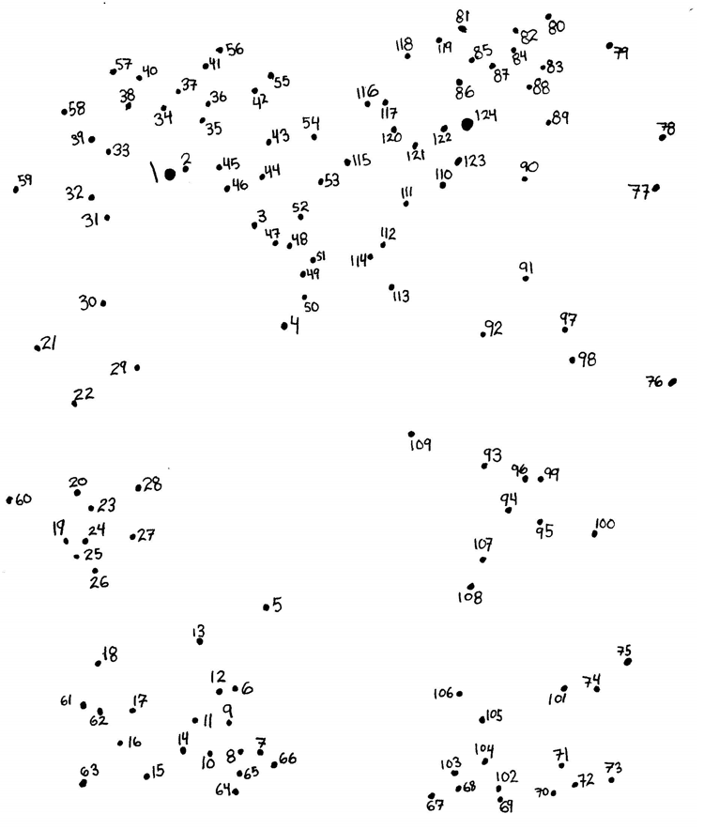
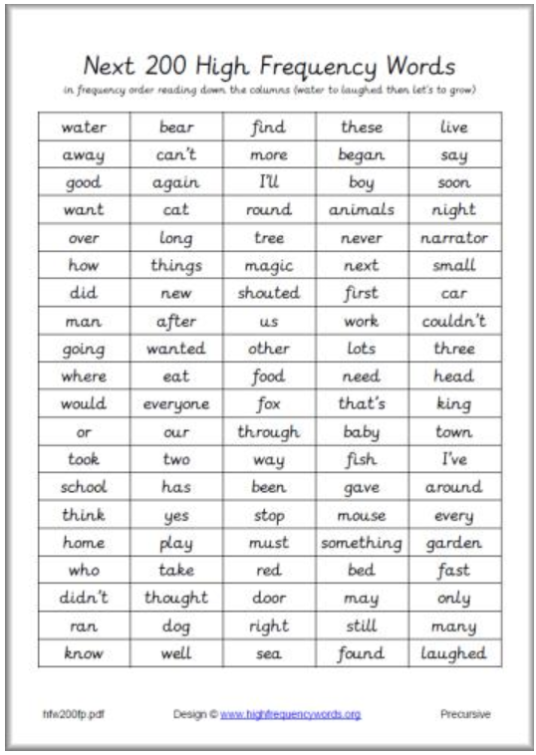

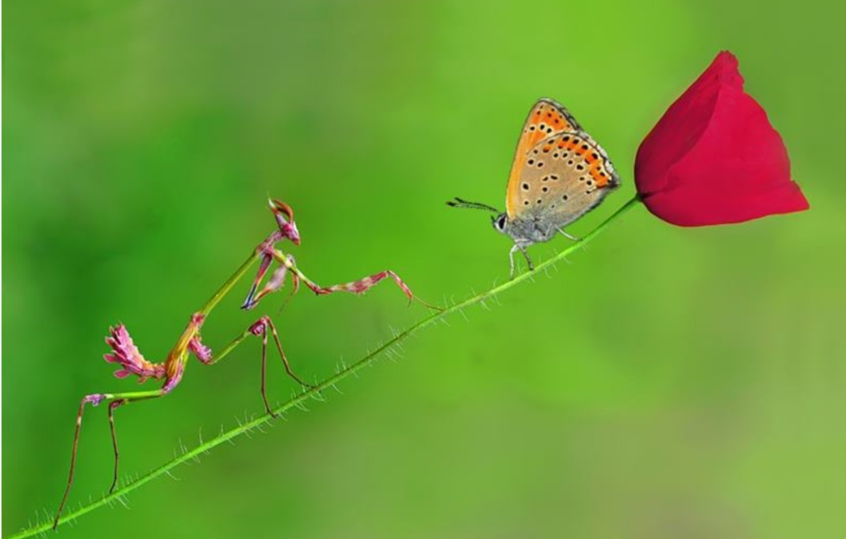

Think about:-
Who is in the picture?
Where are they?
What are they doing and why?
When is this happening?
What do you think they are saying to each other?
What might happen next?
Remember to:-
- Use capital letters, full stops or exclamation marks.
- Use interesting sentence openers
- Read your sentences to make sure they make sense
Extra challenge
See if you can use conjunctions in your sentences.



Remember to:-
- Use capital letters, full stops or exclamation marks.
- Use interesting sentence openers
- Read your sentences to make sure they make sense
Extra challenge
See if you can use conjunctions in your sentences.
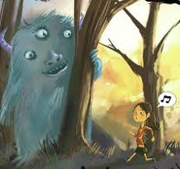
Think about:-
Who is in the picture?
Where are they?
What are they doing?
What do you think they are saying to each other?
What might happen next?

